Multimedia – Journal/Report

IPT HSC Assignment 1

Cherrybrook Technology High School

S. Adeel Asghar

I intend to create an educational website via Adobe Dreamweaver based on the 5 software development approaches; Structured, Agile, Prototyping, RAD and End-User Approach. I aim to incorporate 8 pages throughout my website; 1 for each approach, a summary page, a home page and a help page. Within each page describing each approach I aim to write 1-2 paragraphs explaining what each is and how each is used and when it’s best to use each along with advantages and disadvantages of each.

I will need to understand how to add pages and link them to the headers across each page as hypertext, how to make each page layout consistent and attractive prior to creating my website using Adobe Dreamweaver and how to embed video and audio files. The syllabus dot points that I will be focusing on will be the first 5 of the below image:

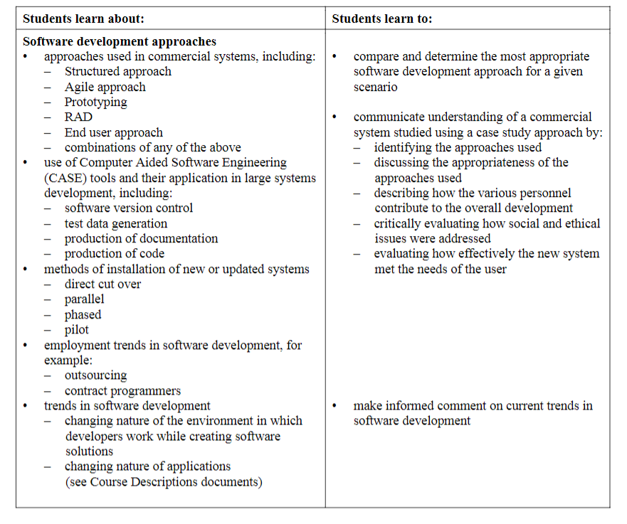

# Software and Hardware Used

**Adobe Dreamweaver –** I have used taken full advantage of the features available throughout Adobe Dreamweaver and have used it extensively to develop the website for my assignment. Adobe Dreamweaver has enabled hypertext writing, layout modification, text editing and overall website creation.

**Microsoft Word –** Has been used to type out this report through a text editor for submission as part of my assignment alongside my website.

**Microsoft Excel –** Used to create the Gantt chart to prioritise tasks and monitor progress.

**Google Chrome –** Used broadly to research how to accomplish multiple functions such as enabling hypertext, embedding video and audio, setting a template, how to use Adobe Dreamweaver and many more.

**PC –** My PC was used extensively to complete all set tasks including the website development, documentation, planning, designing, implementing, imbedding, researching and editing.

**Keyboard –** The built-in keyboard within my PC was also used extensively to type all text within my report and website to convey to the reader/visitor what I’ve done, how and what my topic is about.

**Mouse –** I have used both the built-in mousepad and a Bluetooth mouse to move components of my website, edit my website and report, navigate through my PC to complete this assignment.

**USB –** The external USB drive that I have used to hold my assignment folder was used for submission and testing of my website on another PC/desktop.

**RAM –** The 8Gb Ram within my PC was crucial to creating, typing, saving and editing of both my website and report.

# Feasibility Study

**Technical –** When using Adobe Dreamweaver for the first time it was free to download using the Adobe Creative Cloud, however, I needed to learn how to use the software such as making hyperlinks, text editing, image uploading and template design. All technology required was readily available to me for use within my assignment. Users of my website will be visitors of my website online via the WWW or those who hold possession of my USB or have access to the school’s internet and the M Drive. The participant only requires basic computing skills common when using similar programs such as Microsoft Office apps.

**Operational –** Majority of people who wish to visit my website will have easy access, considering they have an internet connection to view the URL/M drive. Use of a website is very intuitive and easily learnt by new users/visitors from the perspective of the developer using the school internet. The website will be uploaded onto a public drive available over the school network, for this to occur I must obtain permission from the firewall of the WIFI to safely and securely upload my URL. As there are no other developers/programmers there is no need to pay or schedule training.

**Economical –** I have spent zero (0) expenses on developing my website and typing documentation as all resources were obtained for free through Office Home and Student packages and Adobe Creative Cloud to download and use Microsoft Word and Excel and Adobe Dreamweaver. Only if I decide to publish my website I require to pay Adobe for a hosting html live on the WWW.

**Schedule –** this assignment has a limited amount of time to be completed; until the 22nd of February, If I fail to complete and submit my assignment on time consequences persist such as reduced marks. To view to the amount of time prioritised for each task, refer to the Gantt chart spread over 25 days, from the first day when the assignment was received to the date of submission.

# Media Types Used

**Text –** Used throughout my report and website to convey information and explain in detail what I’ve done and how. Within my website, text has been used broadly to input information for the user/viewer to read and understand the chosen topic.

**Numbers –** Used within my Gantt chart to represent time, over days until the due date of this assignment.

**Hypertext –** A crucial feature of my website which allows the user to move between each page easily and intuitively with minimal effort. It allows the user to navigate through my website to view each page in any order.

**Images –** Displayed throughout my website within each page to add an extra element to the design aspect and improve aesthetic presence.

**Animation –** By incorporating GIF image files into my website I have successfully implemented elements of animation into some of the pages to make each page more interesting and attractive.

**Video –** I have been able to successfully incorporate a 6-minute video into my summary page which summarises each of the 5 approaches and explains their pros and cons using different names for each approach. The video is embedded within my website and is playable using the video player screen within the summary page, however, internet is required to play the video as it is fetched from YouTube.

**Sound –** Sound was difficult to implement within my website, however, I have been able to embed a pre-recorded audio clip into my summary page using my own voice which summarises each approach. This works and is available on both the USB and my PC folder.

# Context Diagram

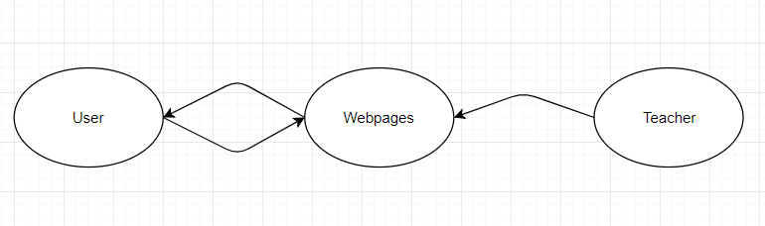

# Data Flow Diagram

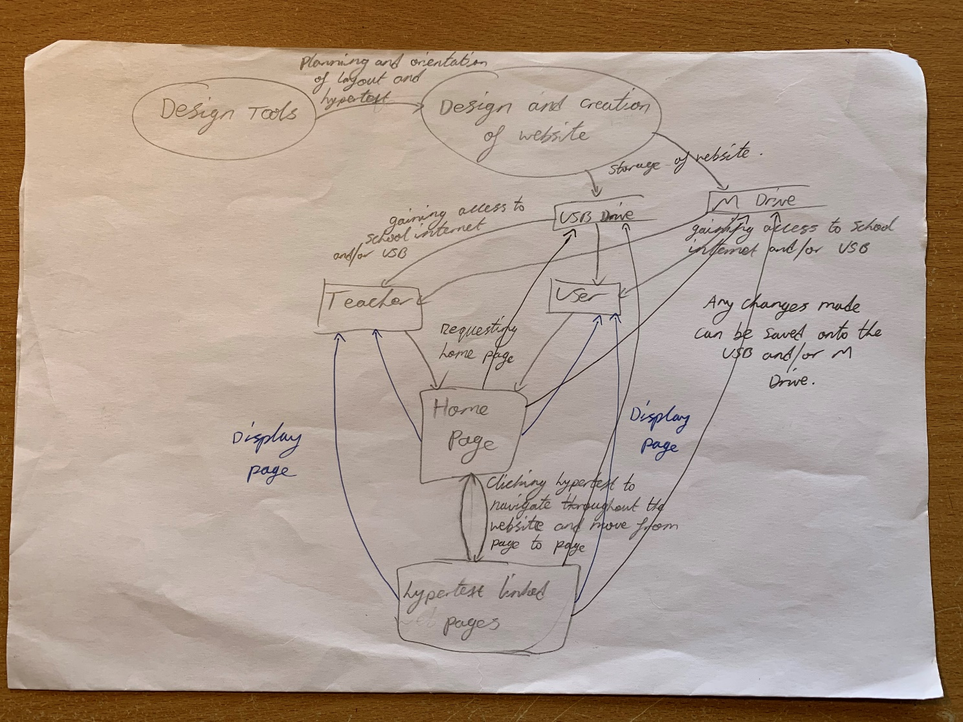

# Decision Table

|  |  |  |  |  |  |  |  |  |  |
| --- | --- | --- | --- | --- | --- | --- | --- | --- | --- |
|  | **Outcome** |  |  |  |  |  | |  |  |
| **Rule** | **1** | **2** | **3** | **4** | **5** | **6** | **7** | | **8** |
| *Clicks/opens page using hypertext* | *user starts on home page regardless* Y | N | N | N | N | N | N | | N |
|  | N | Y | N | N | N | N | N | | N |
|  | N | N | Y | N | N | N | N | | N |
|  | N | N | N | Y | N | N | N | | N |
|  | N | N | N | N | Y | N | N | | N |
|  | N | N | N | N | N | Y | N | | N |
|  | N | N | N | N | N | N | Y | | N |
|  | N | N | N | N | N | N | N | | Y |
| **Outcome** |  |  |  |  |  |  |  | |  |
| *Open:* | Home page | Structured page | Agile page | Prototyping page | RAD page | End-User page | Summary page | | Help page |

# Decision tree

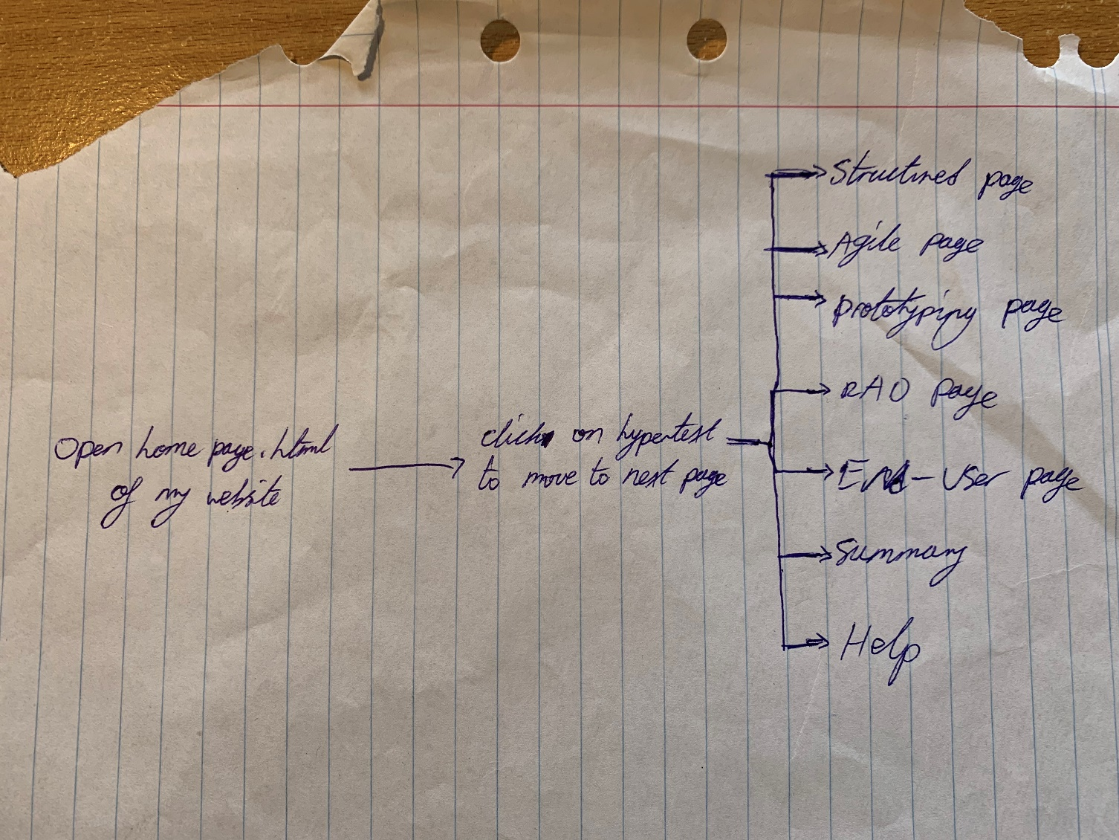

# Storyboard

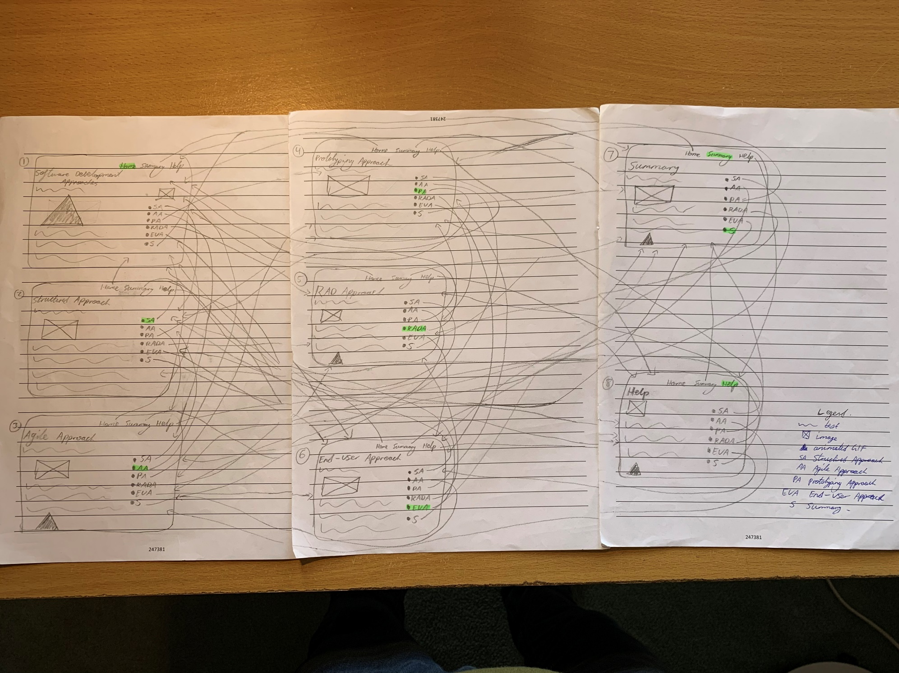

# Gantt Chart

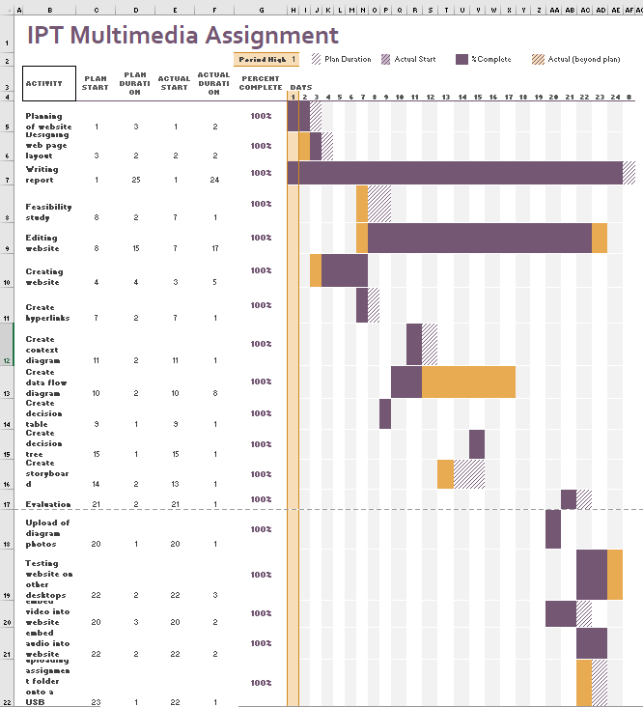

I have been able to complete and submit each component of my assignment on time before the due date. Refer to Gantt chart spreadsheet via the Excel file available within my assignment folder to examine the progress over days from the start to the end in clearer quality.

# Journal

**30th January**

The first day of receiving this assignment I have:

* Created my Gantt chart to get a better understanding of how what I need to do prior to completing my assignment
* Decided on which topic I will base my website on; the 5 software development approaches available
* Researched on tutorials for how to do certain functions in Dreamweaver, such as creating new pages and hyperlinks

**31st January**

The second day of working on this assignment I have made subtle progress towards completion, I have:

* Chosen a template to use for my website
* Began thinking about the layout and design of my website using hyperlinks
* Organised my Gantt chart better

**1st February**

During the IPT lesson today and at home I have:

* Researched into how to make multiple pages within my website
* Began documenting my progress; this report/journal
* Wrote the first paragraph onto the home page
* Added images into my website
* Organised the layout of information within my website

**2nd February**

At home I have been able to:

* Organise my website
* Research how to add new pages
* Research how to link pages together using hyperlinks
* Updated my Gantt chart
* Plan out the design of my website and how I will link pages together

**3rd February**

Whilst at the library I have:

* Written out the first 4 pages; including images and text
* Experimented using hyperlinks
* Worked on my report

**4th February**

At home I have:

* Written up 1 more page for my website
* Updated my Gantt chart
* Worked on this report

**5th February**

Today in class i:

* Finished writing up all my pages
* Figured out how to link pages using hypertext
* Worked on the report
* Updated my Gantt chart
* Hyperlinked all pages together

**6th February**

In class and at home i:

* Edited my website; changing colours and making it more attractive
* Worked on report
* Updated Gantt chart
* Made decision table

**7th February**

At home i:

* Uploaded images and GIFs into my website
* Created the Data Flow Diagram
* Edited my report
* Edited my website
* Updated my Gantt chart

**10th February**

In progression to complete this assignment I have:

* Created my storyboard to represent my website
* Updated my Gantt chart
* Edited this report
* Edited my website

**8th February**

Today i:

* Created the context diagram
* Edited my report
* Update the Gantt chart
* Edited my website

**11th February**

Today i:

* Re-did my storyboard to more accurately reflect what my website looks like as an overview and how each page interacts with the others
* Researched how to add videos into my website

**12th February**

Today I have been successful in doing:

* Creating my first draft of the DFD
* Adjusting the storyboard
* Editing my website

**13th February**

In class i:

* Re-did my DFD to more accurately reflect the flow of data throughout my website
* Edited my report
* Updated my Gantt chart

**14th February**

At home i:

* Re-did my third draft of the DFD
* Created my decision tree

**15th February:**

* Edited my report
* Updated my Gantt chart

**16th February**

At home i:

* Edited my report
* Edited my website
* Recorded voice summary of each approach to embed into my website
* Took pictures of my DFD, storyboard and decision tree
* Uploaded pictures of my DFD, storyboard and decision tree into my report

**17th February**

During the weekend i:

* Updated my Gantt chart
* Edited my report
* Did the bibliography
* Edited my website and font sizes

**18th February**

In class i:

* Embedded video into my website from YouTube
* Edited my website

**19th February**

During the double i:

* Embedded the audio recording of my summary into my website
* Edited my website
* Altered colours and font sizes throughout
* Edited my report

**20th February**

In class i:

* Successfully made the audio clip available on both my USB and PC individually
* Edited my report
* Updated my Gantt chart
* Altered the colours and font style of my text

**21st February**

At home i:

* For the last day of being able to work on this I edited my website
* Edited my report
* Edited my Gantt chart
* Tested my website on numerous devices
* Organise my folder for submission

I intend to submit my assignment tomorrow; 22nd February, in first period during my free period.

# Summary of Assignment

I have been able to complete every concept of this assignment to the best of my ability consistent to a high standard. The outcome of my effort has been achieved within a reasonable time frame and I am very happy with the finished website and report. There were many obstacles which took some time to overcome and achieve my desired outcome. Such obstacles include, linking pages using hypertext and embedding video and audio files/links.

I have worked hard from the beginning of the assignment till the end to achieve what I have produced. I worked in the opposite way form the standard method as I developed the website first then produced the documentation after. This made the process a little more difficult, but I managed to present an excellent final product nonetheless.

My website is based on the 5 software development approaches; structured, agile, prototyping, RAD and end-user accompanied with 3 more pages; home, summary and help. In total I have designed 8 pages all linked to each other using hypertext allocated at the top and side of each page for easy and consistent navigation throughout my website.

The documentation provided consists of the design tools used; context diagram, Data Flow Diagram, storyboard, decision tree and table, overview of the assignment, journal and the summary/evaluation. I have been able to successfully adhere to the criteria of this assignment and deliver a well-presented and finished product consisting of my website, documentation and Gantt chart.

# Evaluation

Throughout my assignment I have been very success in most processes and tasks, being able to complete all components adequately to a sufficient standard. Through the struggles and obstacles, I have been able to produce a working website with full report to support.

When developing my website, I worked in the opposite direction and created my website before beginning the documentation, by doing so I had no set plan of what I expected my website to look like in the end and created difficulty in the documentation towards making the diagrams.

I spent many hours deciding how to create my website and figuring out how to complete tasks such as set up hypertexts, edit aesthetics and import videos. A major issue occurred as I completed my website and was in the stages of editing which removed the purple colour of the banner at the top of every page. To resolve this issue, I closed Dreamweaver which worked.

Other issues that were encountered was regarding saving my audio clip of the summary on both my USB and PC, so it would be playable on both devices. Being able to make the audio clip available as a portable file linked to my USB website and the other for my PC was difficult but I altered the route used for each so that both can be used, and this worked.

Multiple other issues such as creating hypertext links, embedding video and sound were also encountered.

When writing the documentation, I did have some difficulty as I had to create the planning after creating the website which presented some issues. I was required to recreate my diagrams multiple times over prior to submission to accurately and correctly reflect the presentation and organisation of my website. My DFD and context diagrams were the hardest to create as there were multiple variables which needed to be considered for both part A and B; multiple hypertext links between each page within each page. I made many different iterations before arriving at the final diagram for submission alongside the website, within the report.

There were many issues which required me to learn how to overcome such as embedding video and audio into my website, creating hypertext links and creating a consistent template to use throughout all my pages. The load times of the video from YouTube is dependant on the network connection the user has available at that time.

However, through all the complications I have been able to triumph and develop a working website with hypertext links, video and audio, a consistent design, images, animations/GIFs and many more features with all documentation and design tools to accurately reflect alongside.

Whilst testing my website I observed that using a modern browser such as Google Chrome was better suited to running a HTML5 file compared to Microsoft Edge and Internet Explorer. When using a modern browser, it allowed all features to display as it appeared in Dreamweaver but when using other older browsers such as Internet Explorer features of my website would not display properly such as set formats and layouts of text and headers/footers. Therefore, it is recommended to use a modern browser when viewing my website.

I am very satisfied with the result and have come a long way from the beginning of this assignment, being able to learn a lot more than I would’ve expected to achieve what I have submitted. I believe my assignment meets all criteria requirements to the best of my ability.

# Bibliography

* <https://www.purplezeus.com/software-development-approaches.html>
* <https://websitesetup.org/dreamweaver-tutorial/>
* [https://docs.google.com/document/d/1rjs4buMnRVWQcywI0Hfnv1_cKUh5P18uvj48BR3ris4/edit#](https://docs.google.com/document/d/1rjs4buMnRVWQcywI0Hfnv1_cKUh5P18uvj48BR3ris4/edit)
* <https://helpx.adobe.com/dreamweaver/how-to/make-hyperlink.html>
* <https://www.draw.io>
* Sam Davis IPT HSC textbook (pages 68-73, 53-58)
* <https://www.youtube.com/watch?v=aM8rvSOukpE>
* <https://www.tutorialrepublic.com/html-tutorial/html5-video.php>
* <http://wreckitmate.blogspot.com/2014/09/symbols-used-in-dfds.html>
* <https://www.cleveroad.com/blog/a-fresh-take-on-5-software-development-methodologies>
* <https://www.youtube.com/?feature=youtu.be>
* <https://www.youtube.com/watch?v=M4KDH9H_uH0>